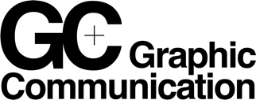
A Level Graphic Communication

Summer Task

4 Self-Portraits*

• Each self-portrait should be double the size of the previous, starting with a drawing approximately 2cm x 2cm, then 4cm x 4cm, 8cm x 8cm, and finally 16cm x 16cm

• Set a timer and spend a different amount of time making each self-portrait.
1 minute, 10 minutes, 30 minutes & 60 minutes.

Each time you make a self-portrait use a different material or process to make the image. You can use any material or process you like, but the more unusual the method the better. Try using something more interesting than just shading in pencil! Research the references to artists/designers (below) to help with your ideas/methods.

Underneath the self-portraits describe, in no more than 200 words, why you made the images in the way you made them. What were the challenges you faced? Who’s work were you referencing (see below)? Did anything surprising or interesting happen when you were making the images? You can word-process or hand-write. Your self-portraits can be literal, observed or more weird / conceptual…

Bring the A4 page with your Self-portraits & writing with you to the Graphics Studio for the first session (this task should take no longer than 2½ hours to complete).

References: Frida Kahlo, Gavin Turk, David Hockney, Vic Muniz, Andy Warhol, Salvador Dali, Vivian Maier, Stefan Sagmeister, Dan Hillier, Chuck Close, Cindy Sherman, Pablo Picasso (these are a starting point and you must also look for your own references).

--

*A Self-Portrait can be defined as:
“a picture, photograph, or piece of writing that you make of or about yourself “
(Cambridge English Dictionary)
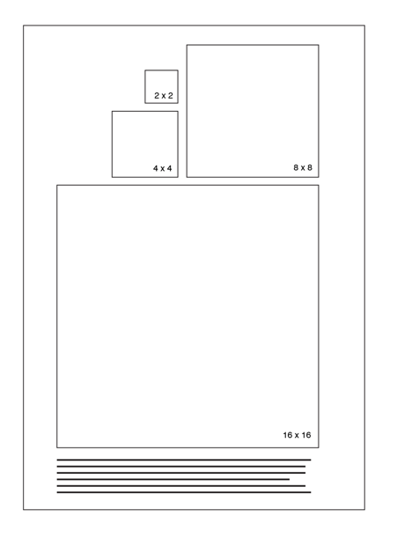

Example A4 layout with 4 self-portraits and text below.

