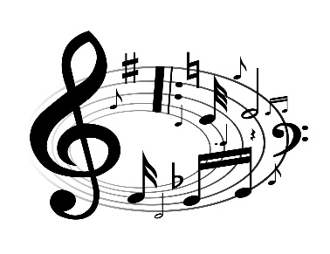
A LEVEL MUSIC

Music Theory
Before you start the A level Music course it will be really useful to know some theory. If you’ve already taken Grade 5 theory, that’s great. If you haven’t then it would be useful to find some time before you start the A level course to boost your theory knowledge.
A couple of useful websites are www.musictheory.net and www.teoria.com but there are many more out there, as well as some useful YouTube videos.
The Open University also provide a free Introduction to Music Theory online course and you get a certificate of completion when you’re done!! Just search ‘OU introduction to music theory’ and you should find it.

Performance
You should be at least working towards a Grade 5 standard (instrumental grades not GCSE grades!) when you start the course (an informal audition will take place if you haven’t taken practical exams).
So, keep practising your instrument/s between now and the start of the course. In the second week of the course you will perform a piece you have chosen to the teacher, so get practising something that shows off what you can do! We’ll call it your Party Piece.

Composition
You are required to compose as part of the A Level Music course. Before you start the course I would like you to compose a short piece in whatever style and for whatever instruments/voices you like based on the subject of ‘Birds’. It needs to be at least 30 seconds long and you will need to submit an audio file of it when you start college. That can be computer/software generated or a recording of a live performance or a combination of the two.
You might want to listen to some of these for inspiration:
The Swan – by Saint Saens https://www.youtube.com/watch?v=b44-5M4e9nI
The Aviary – by Saint Saens https://www.youtube.com/watch?v=y1PQRu_C5fQ
Blackbird – by The Beatles https://www.youtube.com/watch?v=Man4Xw8Xypo
Albatross – by Fleetwood Mac https://www.youtube.com/watch?v=wOJeMv1zNDY
La Gallina (the hen) – by Respighi https://www.youtube.com/watch?v=LYJ8JdGFiNw

Music History
Before you start the course, choose one of the following composers or artists and create an informative A4 poster about their life/career and their work. You will study them in your first year.
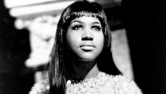
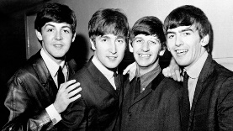
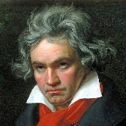
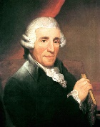
Joseph Haydn Ludwig van Beethoven The Beatles Aretha Franklin

