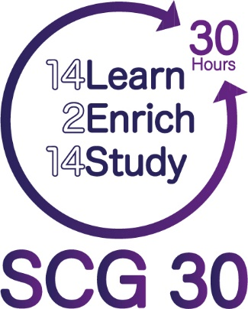
Preparing to succeed in
A-level Statistics
Summer Preparation Work
Name:

Welcome to college and to the Mathematics Department.
You will have a long break this summer and may well find that you get rather rusty at some of the maths skills which you spent so long learning at school.
This booklet contains some of those key ideas from GCSE which will help you to make a good start on the A-level course. Please work through this booklet over the summer to keep your skills up to speed.
Please make a good attempt at every question - we’d rather it was wrong than blank as it helps us to see where you may need some help! It’s fine to look things up in your old books, or look at websites like BBC GCSE Bitesize to get some help if you need it.
Please set out all of your working carefully.
Hand in your completed booklet to your teacher on your first statistics lesson – this may be your first day in college so make sure you bring it with you!
There will be a small assessment based on this work in your second lesson!

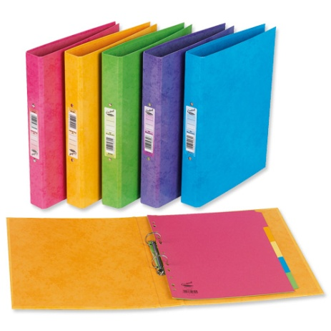
Preparing for lessons in September – please bring:
- A4 file paper (lined not squared is preferable)
- A ring binder folder with some file dividers
- Pens and pencils
- Highlighter pens
- This booklet to hand in!

Numerical work

In statistics it is important to be able to work with fractions, decimals and percentages. Other numerical skills involve rounding decimals and using significant figures.

Example: Increase 15 by 20%.
Ans:
15 + 20% of 15
20 % of 15 is $\frac{20}{100}×15=3$
15+3 = 18

Faster Alternative: An increase of 20% means we will end up with 120%
$$15×120\%=15×1.2=18$$

Example: Decrease 70 by 40%
Ans:
70 - 40% of 70
40% of 70 is $\frac{40}{100}×70=28$
70 – 28 = 42

Faster Alternative: A decrease of 40% means we will end up with 60%
$$70×60\%=70×0.6=42$$

Example: Calculate the percentage increase of 50 to 70

Ans:
$$percentage change=\frac{difference between values}{Original Value}×100$$

$$\frac{70-50}{50}×100=40\%$$

Example: Reverse percentage – A product is on sale, and it’s sale price is £24. The sale amount is 20% off. How much did it originally cost?
Ans:
Treat this as a ratio.
20% off means the product is now 80% of the previous value.
$$80\%:24 \\ 0.8 :24$$We want to know what 100%, or 1 : n is.
Divide both sides by 0.8
$$1 :\left(\frac{24}{0.8}\right)=30$$
The original price was £30.

Alternative:
If $p$ is the original price, then
$$0.8×p=24$$

$$\frac{24}{0.8}=p=30$$

Examples to do:
- (a) Lisa sees a dress in a sale.
The normal price of the dress is £45
The price of the dress is reduced by 12% in the sale.
Work out the price of the dress in the sale.

£...........................................................

(b) Lisa's weekly pay increases from £525 to £546
Calculate her percentage pay increase.

...........................................................%

(c) Lisa sold a car for £2240 having made a loss of 30%. How much did she originally pay for the car?

£...........................................................
(d) Lisa is selling a new car.
The car costs £15,000.
Lisa reckons she can increase the cost of the car by 6.5% due to demand.
Work out the price of the car now.

£...........................................................

- (a) Work out the value of $\frac{\sqrt{7.4}}{9.8-2.2}$

Give your answer as a decimal.
Write down all the figures on your calculator display.
...........................................................

- Give your answer to part (a) correct to 3 significant figures.

...........................................................
- Give the value of 2.91² correct to 2 decimal places.

...........................................................

3. (a) Write 64% as a decimal.

...........................................................

(b) Write 9% as a decimal.

...........................................................

4. Here are five decimal numbers:
0.16 0.06 0.007 0.41 0.032

(a) Write down the numbers in ascending order.
...........................................................
(b) Write 0.16 as a percentage.
...........................................................
(c) Write 0.032 as a percentage.
...........................................................

Algebra
It will be necessary to substitute numbers accurately into formulae and also to solve simple equations.

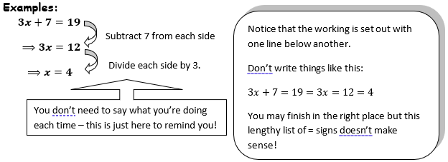
Examples to do:
1. Solve the equation $4x-5=17$
x = .........................
2. Solve the equation $7.31-b=2.56$
b = .........................
3. Solve the equation, giving your answer to 3 significant figures: $\frac{10}{s}=4.63$

s = .........................
4. $z=\frac{23.6-m}{\sqrt{v}}$. Find the value of z to 2 decimal places when $m=20$ and $v=10$

z = .........................

Averages and Measures of spread.

You will be required to calculate all three types of average (mean, median and mode) and to be able to find the range and interquartile range from sets of data.

Examples:
- From the list of numbers below, find the:
a) mean, b) median, c) mode, d) range,
e) first quartile $Q_{1}$, f) third quartile $Q_{3}$, g) interquartile range
10, 15, 29, 30, 31, 31, 50,
Ans:
The mean is calculated by adding them all up and dividing by how many there are.
$$\frac{10+15+29+30+31+31+50}{7}=28$$
The median is found by writing the numbers in order of size, and finding the middle one.
You can cross through the numbers (one from the left, one from the right) until you get to the middle
10, 15, 29, 30, 31, 31, 50,
10, 15, 29, 30, 31, 31, 50,
10, 15, 29, 30, 31, 31, 50,
The median is 30.
Faster Alternative:
Add one to the total amount of data, and divide that by 2. This tells us the position of the median.
$$\frac{7+1}{2}=4th$$
The 4th number in the list is the median. That’s 30. (We’ll use this method for quartiles).
The mode is the most common number in the list.
This would be 31.
The range is the highest value take the lowest. In this case, $50-10=40.$
The first quartile is found by going 1 quarter into the data.
$$\frac{1}{4}\left(7+1\right)=2nd$$
The 2nd number in the list is the first quartile, 15.
The third quartile is found by going 3 quarters into the data.
$$\frac{3}{4}\left(7+1\right)=6th$$
The 6th number in the list is the 3rd quartile, 31.
The Interquartile range is found by doing:
$$3rd quartile – 1st quartile = 31 – 15 = 16$$
Height (cm) | Frequency
$$120≤x<130$$ | 1
$$130≤x<140$$ | 3
$$140≤x<150$$ | 6
$$150≤x<160$$ | 6
$$160≤x<170$$ | 10
$$170≤x<180$$ | 20
$$180≤x<190$$ | 5
$$190≤x<200$$ | 1
- Find:
a) an estimate for the mean
b) the median class
c) the modal class

Ans:
This is grouped data as it has class intervals. This means we can only do things regarding classes or estimates by using the midpoint. You will not need a midpoint if the data is not grouped.
Height (cm) | Frequency | Midpoint | Midpoint$×Frequency$ | Cumulative Freq
$$120≤x<130$$ | 1 | 125 | 125 | 1
$$130≤x<140$$ | 1 | 135 | 405 | 2
$$140≤x<150$$ | 6 | 145 | 870 | 8
$$150≤x<160$$ | 6 | 155 | 930 | 14
$$160≤x<170$$ | 10 | 165 | 1650 | 24
$$170≤x<180$$ | 20 | 175 | 3500 | 44
$$180≤x<190$$ | 5 | 185 | 925 | 49
$$190≤x<200$$ | 1 | 195 | 195 | 50
 | 50 |  | 8330

Total MPxFreq = 8330 Total Frequency = 50
$$Mean=\frac{8330}{50}=166.6$$

The median occurs in halfway in the frequency.
The 25th one occurs when the cumulative frequency goes over 25.
$$160≤x<170$$ | 10 | 165 | 1650 | 24
$$170≤x<180$$ | 20 | 175 | 3500 | 44

The median class is $170≤x<180$.
The modal class is the one with the highest frequency. That’s also $170≤x<180$.
Questions:
- From the list of numbers below, find the:
a) mean, b) median, c) mode, d) range,
e) first quartile $Q_{1}$, f) third quartile $Q_{3}$, g) interquartile range
3, 3, 4, 4, 4, 5, 5, 10, 14, 40, 50,

Mean = ........................., Mode = .........................,
Median = ........................., Range = .........................,
$Q_{1}$= ........................., $Q_{3}$= .........................,

$IQR=$........................,

x | Frequency
2 | 17
3 | 15
4 | 33
5 | 22
6 | 10
9 | 7
14 | 1

- Find:
a) an estimate for the mean
b) the median value
c) the modal value
Mean = ........................., Mode = ........................., Median = .........................,
Height (cm) | Frequency
$$100≤x<130$$ | 1
$$130≤x<140$$ | 1
$$140≤x<150$$ | 0
$$150≤x<160$$ | 0
$$160≤x<170$$ | 7
$$170≤x<180$$ | 5
$$180≤x<190$$ | 2
$$190≤x<210$$ | 1
- Find:
a) an estimate for the mean
b) the median class
c) the modal class

Mean Estimate = ....................., Modal Class = ....................., Median Class = .....................,

- The calculated mean test score of 9 students from a statistics class was 55. However, one score had accidentally been recorded as 47 instead of 74. Find the correct value for the mean score.

- The mean test score for 20 students in one class was 70. The mean test score 30 students in another class was 85. Find the mean test score for the combined group of students.

Statistical Diagrams:
Make 3 comments each about the 2 following diagrams.
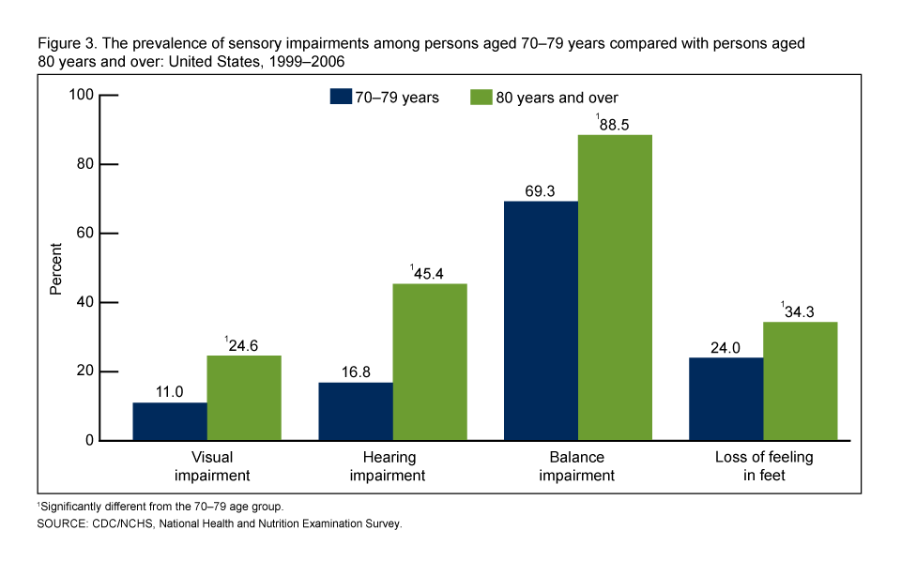

Research task
Research the normal distribution – write down three key facts about this distribution.

Give examples of three quantities/variables which could be modelled by a normal distribution.

Extension: Probability comes up later in the course!
Each student in a group of 32 students was asked the following question.
"Do you have a desktop computer (D), a laptop (L) or a tablet (T )?"
Their answers showed that
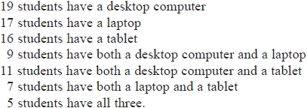
- Using this information, complete the Venn diagram to show the number of students in each appropriate subset
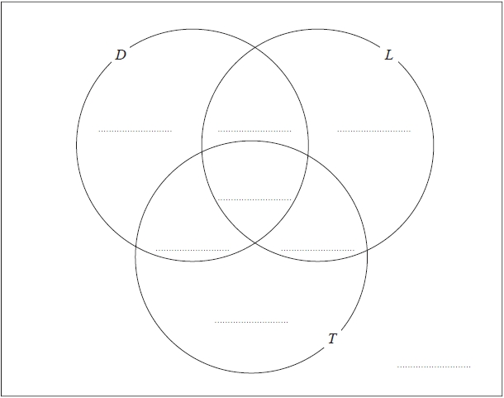

One of the students with both a desktop computer and a laptop is chosen at random.
(b) Find the probability that this student also has a tablet.

...........................................................

