Summer Research Tasks

Art & Design in Context

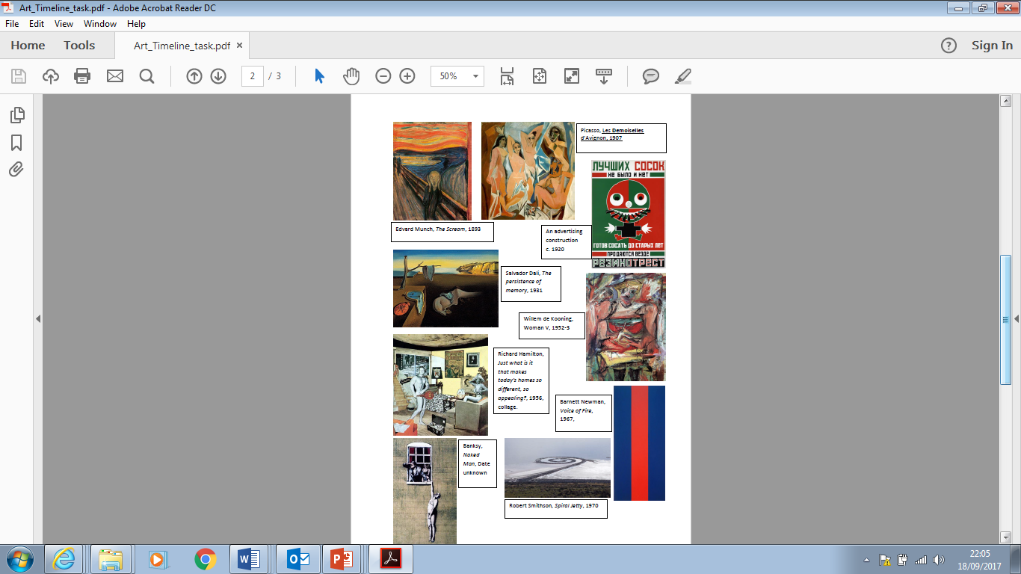 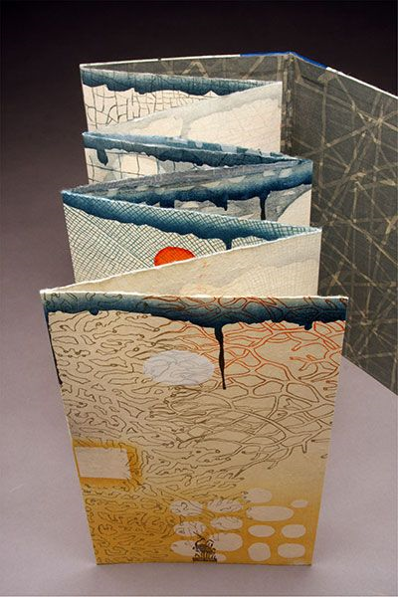

**Tasks:**

1. Use books, magazines, the internet, Instagram, Pinterest etc. to explore art in context and art & design history.
2. What is your main area of interest in visual art & design?

* Research your own area of interest.

* Consider how it links to a theme, style, art movement, culture, or period/decade.
* Select a range of artists or designers from the area and investigate their work.
* Select 1 to investigate further (ensure this is an artist/designer who you find interesting and influences you).
* Follow the ‘6 simple steps for artist research’ to investigate, analyse and work in the style of this artist/designer.
* Add all your findings and imagery to A3 paper.