Year 11 Summer homework

NAME: …………………………………………………………………
SCHOOL: …………………………………………………………….
COURSE APPLIED FOR ………………………………………..

ABOUT YOUR COURSE
- For each unit of study, you will sit an externally set, online multiple choice exam.
- You will complete practical assessments and demonstrate services on clients within a commercial time for each unit.
- The overall grade for the course you are studying is marked as pass / fail.
- The grades for the online exams are marked as pass/ fail.
- Level 1 – practical assessments are graded as pass/ fail.
- Level 2 – practical assessments are graded as pass/ merit/ distinction (or fail.)
Your course tutor will explain the grading and assessment criteria once we are sure you are on the correct level of course and you receive your portfolios.

WHAT YOU NEED TO DO OVER THE SUMMER

- It is highly recommended to be working (even if it is voluntary) in a salon whilst studying your qualification in the Academy. This experience has proven to improve grades and aid progression to the next level. Please do your very best to secure a placement.
- Complete this booklet and bring in on your first day.
- Order kit and uniform/ apply for a bursary ASAP! You will also need to order black closed toed shoes (no trainers/ pumps/ ugg boots or sandals.)
- Purchase 2 folders, 2 sets of dividers and pens for study.
- Create a CV

Completion tips
Before you start this booklet
- Be familiar with the structure of the questions (how many marks are awarded for each question etc)
- Use books / internet / magazines to help your research.
- This will be used as a form of initially assessing your ability. Please try your very best and do not ‘copy and paste.’

SAFETY FIRST!
WHILST STUDYING YOUR QUALIFICATION, YOU WILL BE PRACTICALLY ASSESSED ON KEEPING YOURSELF AND YOUR CLIENTS SAFE ON THE SALON WHILST ADHERING TO LEGISLATION. YOU WILL ALSO SIT AN ONLINE EXAM FOR HEALTH AND SAFETY.

Differentiate between a hazard and a risk (2 marks)
…………………………………………………………………………………………………………………………………………
…………………………………………………………………………………………………………………………………………
…………………………………………………………………………………………………………………………………………
………………………………………………………………………………………………………………………………………….

Give 2 examples of a hazard and record their associated risks (4 marks)
…………………………………………………………………………………………………………………………………………
…………………………………………………………………………………………………………………………………………
…………………………………………………………………………………………………………………………………………
………………………………………………………………………………………………………………………………………….

State why a risk assessment is used in the salon (1 mark)
…………………………………………………………………………………………………………………………………………
…………………………………………………………………………………………………………………………………………
…………………………………………………………………………………………………………………………………………

What is Contact dermatitis? (1 mark)
…………………………………………………………………………………………………………………………………………
…………………………………………………………………………………………………………………………………………
………………………………………………………………………………………………………………………………………….

Describe the causes, (2 marks) symptoms (2 marks) and preventions of contact dermatitis (2 marks)
…………………………………………………………………………………………………………………………………………
…………………………………………………………………………………………………………………………………………
…………………………………………………………………………………………………………………………………………
………………………………………………………………………………………………………………............................
...........................................................................................................................................
...........................................................................................................................................
...........................................................................................................................................

State the meaning of a legislation (1 mark)
…………………………………………………………………………………………………………………………………………
…………………………………………………………………………………………………………………………………………
………………………………………………………………………………………………………………………………………….

List 5 legislations you will need to adhere to whilst studying in the Academy (5 marks)
…………………………………………………………………………………………………………………………………………
…………………………………………………………………………………………………………………………………………
…………………………………………………………………………………………………………………………………………
…………………………………………………………………………………………………………………………………………
………………………………………………………………………………………………………………………………………….

Communicating with clients and colleagues

Give 4 examples of good personal presentation and hygiene (4 marks) Why is this important? (2 marks)
…………………………………………………………………………………………………………………………………………
…………………………………………………………………………………………………………………………………………
…………………………………………………………………………………………………………………………………………
…………………………………………………………………………………………………………………………………………
…………………………………………………………………………………………………………………………………………
………………………………………………………………………………………………………………………………………….

Give 3 examples of aftercare advice you could give to a client (3 marks) Why is it important to give advice to every client? (2 marks)
…………………………………………………………………………………………………………………………………………
…………………………………………………………………………………………………………………………………………
…………………………………………………………………………………………………………………………………………
…………………………………………………………………………………………………………………………………………
…………………………………………………………………………………………………………………………………………
…………………………………………………………………………………………………………………………………………
…………………………………………………………………………………………………………………………………………
………………………………………………………………………………………………………………………………………….

Give an example of an open closed question (1 mark)
…………………………………………………………………………………………………………………………………………
………………………………………………………………………………………………………………………………………..

Give an example of a closed question (1 mark)
…………………………………………………………………………………………………………………………………………
………………………………………………………………………………………………………………………………………
Hair and skin

- Label the structure of the hair (3 marks)
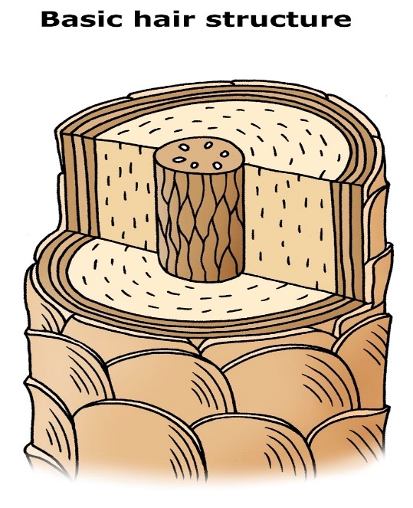

Label the structure of the skin (9 marks)

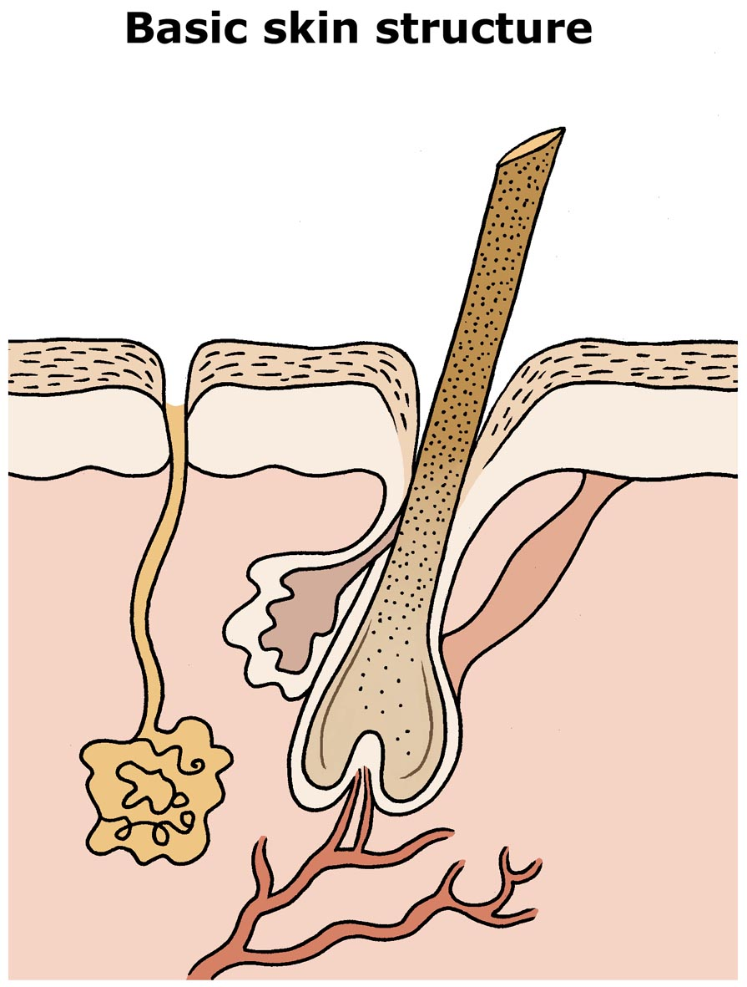
For every chemical service demontrated in the Academy, tests will need to be demonstrated on the hair and skin:
Explain WHY, HOW and WHEN you would demonstrate the following tests:

- POROSITY TEST (3 marks)
WHY

HOW

WHEN

- ELASTICITY TEST (3 marks)
WHY

HOW

WHEN

- INCOMPATIBILITY TEST (3 marks)
WHY

HOW

WHEN

- SKIN TEST (3 marks)
WHY

HOW

WHEN

- COLOUR TEST (3 marks)
WHY

HOW

WHEN

- STRAND TEST (3 marks)
WHY

HOW

WHEN

Please choose 4 styles which you would like to recreate this year
Style 1 | Style 2
Style 3 | Style 4

Complete the following table: (8 marks)

PRODUCTS | PURPOSE
Heat protectors

Sprays
Mousse

Wax

Gel

Draw the colour star and label the primary and secondary colours (8 marks)

