Dan Gibbons
Shrewsbury Colleges group
Level 1 Summer Task: Introduction to employability in the catering and hospitality industry

Level 1 Summer Task
Introduction to employability in the catering and hospitality industry

You are required to research two catering establishments, one from the commercial sector (pub, restaurant, hotel, café etc.) and one from the service sector (school, prison, hospital, care home etc.).

Use the table below to collate information that you discover under each heading.

Choose establishments that you either know personally or that have a good website so that it is easier to gather the relevant information.

For the commercial sector this will be fairly straightforward but it may be more difficult to find specific information on service sector establishments. So, for example, if you choose to research a prison then you may only be able to find general information about prison food and not necessarily about a specific prison.

This is where your research and thinking skills and common sense come in. Try to include as much information as you can in each of the headings.

Good luck and we will see you in September.

Assignment 602 Introduction to employability in the catering and hospitality industry

Candidate Name:

Task A: Information | Commercial Establishment | Service Sector Establishment
Name of establishment
Location
Opening times

Menus (types of menu)

Pricing (include example dishes and prices)

Staffing

Facilities

Additional Information

Sources of Information (websites etc.)

Unit 602 – Task A Assignment Guide – Introduction to the hospitality and catering industry
It is useful to consider, define and explain what the terms ‘hospitality’ and ‘catering’ actually mean. You might want to start by checking a dictionary or online dictionary definition of each term, but use these only as a starting point. Put the definitions into your own words and try to give an example of what you mean for each term.
It is also useful for you to say something about the industry itself. How large is the industry in the UK? How many people are employed in the industry? What jobs are available in the industry and what experience or qualifications might you need to get a job and progress your career in the industry?
You then need to explain something about the two main sectors in the hospitality and catering industry. The two key sectors are ‘commercial sector’ and ‘public sector’. Do some research on this and find out what the difference is between the two sectors. Ask yourself, what kind of businesses would I find in each sector? Are the businesses in each sector offering the same services? Is the main function of all businesses or organisations to make a profit from the sale of food and drink?
‘The Commercial Sector’? ‘The Public Sector’?
There are differences so make sure you explain the main functions of businesses or organisations in each sector. Maybe do this in your introduction before you begin writing about your chosen establishments.

Example
The assignment asks you to choose and research two hospitality and catering operations – one from the commercial sector (hotel, restaurant, café etc.) and one from the public sector (hospital, prison, school etc.).
You need to include information on:
Location – don’t just include the address but say also where it is situated. For example:
The Lord Hill Hotel in Shrewsbury is situated on a busy main route into Shrewsbury, making it easily visible for attracting passing trade. It also has good links to the M54 Motorway for business people and is close enough to the town centre for to attract local business and tourists.
Maybe also include a photograph of the establishment.
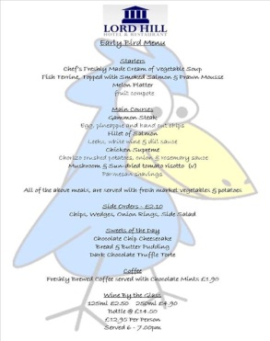
Opening times – try to include as much information as you can about general opening times but also times of restaurants within hotels and times that other facilities may be used by customers (bars, gyms, leisure facilities, spa and beauty treatments etc.)
Menus – include information on all types of menus each establishment uses. For example, some hotels and restaurants may have a la carte menus (items individually priced), table d’hote (a menu with limited choices at a set price), wedding party and buffet menus, bar food menus etc. Give some examples of typical dishes found on the menus and explain why they offer such a variety.
For your public sector organisation, try to find information on menus to show the kind of food they provide. For example, if you choose a hospital or school, call them up or visit and try to speak to someone who can help you obtain copies of their menus. You may be able to find information from hospital or school websites. Only choose somewhere you can find information for and can show examples. Don’t waste time, if you can’t find information on your chosen organisation – choose another!
Pricing – show a range of prices for starters, main courses and desserts or for set menus and party menus.
Staffing – Think about how many departments there are in your chosen establishment. Hotels, for example have a range of departments from reception, bar, housekeeping, kitchen, cleaning, management, front of house etc.
If you are choosing a hospital or school for your public sector organisation, focus on the staff involved in the catering and service side of the operation.
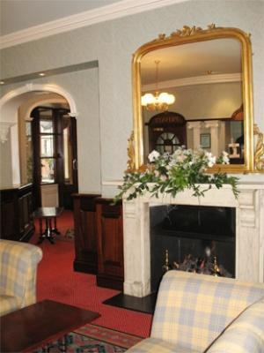
Furnishing – include information about what kind of décor a restaurant has and the type of furnishings it has. Is it old fashioned (traditional) or is it modern (contemporary)?
Say why you think they have styled their restaurant in such a way. What kind of customer are they targeting their business at? Is it family friendly or is it aimed more at business people or at a more affluent clientele? Is it a fine dining experience or a fast food experience?
Facilities – Explain what other facilities your chosen establishments have other than the catering facilities. Consider things like spa facilities, crèches, gym facilities, function rooms, meeting rooms and sports facilities etc.
Make sure you cover all of these features in as much detail as you can. You should aim to produce between 3-4 pages with your font not bigger than 14 point size. Include images and pictures to enhance your assignment and to illustrate some of the features of your chosen businesses or organisations.
If you are unsure about any aspect of this assignment, see your tutor for advice and further guidance.
Extend your research for a better grade
If you do all of the things explained in these guidance notes then you should meet the criteria to achieve at least a pass for the assignment. However, you have the opportunity to achieve a merit or distinction by doing more research and putting more effort into your work.
You could consider ‘tourism’ and how important hospitality and catering are important to the tourism industry worldwide. Do hotels and restaurants differ in other parts of the world and what opportunities are there to work abroad?
Perhaps consider researching and reporting on a hotel or restaurant chain or a hospitality group that have several chain hotels and restaurants within their group.
You could look at airlines or cruise liners and consider the whole package they offer to travellers and holiday makers regarding hospitality and catering.
You could do more research on the industry as a whole and produce some data or graphs to show how important the industry is to the UK economy.
These are just some ideas for you to extend your research, investigate the industry in more detail and to show just how much you know about the industry you have chosen for your career.
Good luck and don’t forget to talk to your tutor for feedback and guidance on your work.

